Name_______________________________Period____Date_________

Physical Science Semester Review #3
Work, Power, Energy, Machines

Concept Questions

- What is energy?

- What is work?

- What is power?

- What is the difference between potential energy and kinetic energy?

- Name and describe the 6 different simple machines.

- Describe the 3 classes of levers and draw a picture of each.

- If you have a MA of 0.85, how does the machine help you?

- If you have a MA of 4.2, how does the machine help you?

- If you have a MA of 1, how does the machine help you?
- What is the IMA of the following pulley systems:
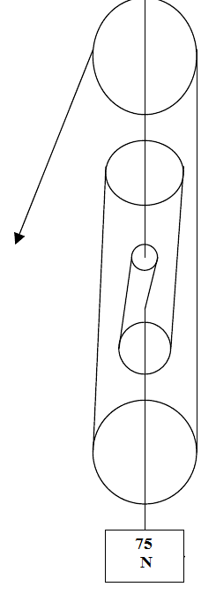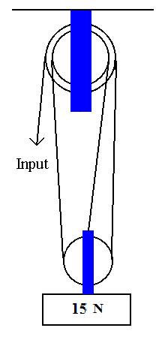
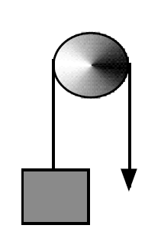
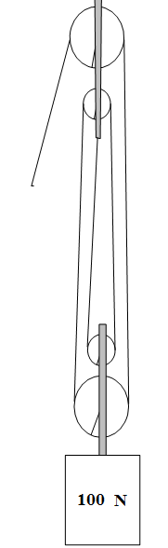

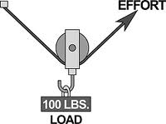

- What is a compound machine?

Math Questions

- How much work is done if Kim lifts a 20N board to the second story of a building that is 15 m tall?

- What power is generated by a plant that does 4530 J of work in 5 seconds?

- What is the potential energy of a 75 kg man standing at the edge of a 75 m cliff? (acceleration due to gravity=9.8 m/s²)

- What is the kinetic energy of a baseball that has a mass of 0.25 kg and a velocity of 40 m/s?

- A lever has a resistance arm length of 3 m and an effort arm of 10 m. What is the mechanical advantage of this simple machine?

- An inclined plane is 20 m long and 4 m high. What is the mechanical advantage of this inclined plane?

- Find the effort force needed to lift a 3600 N rock using a jack with an MA of 6.

- Using a block and tackle pulley system with 3 strands, how much input force will you need to lift a 2400 N object?

- The diameter of a steering wheel in Allyson’s car is 15 inches. The steering column (or the axle of the steering wheel) has a radius of 1.75 inches. What is the mechanical advantage? (BE SURE TO CONVERT DIAMETER TO RADIUS)

- You need to lift an 800 N boulder using only 12 N of force with a first class lever. How long does the lever need to be if the boulder is 0.5 m from the fulcrum?

- An axe is used to split wood is driven into a piece of wood a distance of 3 cm. If the mechanical advantage of the axe is 0.85, how far apart is the wood split?

