Name__________________________________________Period______Date________________

Pulleys Practice

Examine the following pulley systems:

IMA= | IMA= | IMA= | IMA=
Ideally, how much force would you have to exert to lift the resistance? | Ideally, how much force would you have to exert to lift the resistance? | Ideally, how much force would you have to exert to lift the resistance? | Ideally, how much force would you have to exert to lift the resistance?
If needed 15 N of effort to lift, what is your actual MA? | If needed 8 N of effort to lift, what is your actual MA? | If needed 29 N of effort to lift, what is your actual MA? | If needed 20 N of effort to lift, what is your actual MA?
Efficiency? (Honors) | Efficiency? (Honors) | Efficiency? (Honors) | Efficiency? (Honors)
Answer the following questions:

- Design a pulley system with an IMA of 2.

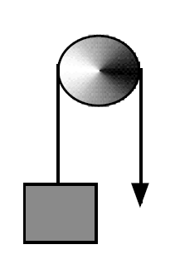

- Use the picture to the right to answer a-e.

  - What kind of pulley is this?

  - On the diagram, draw where the effort force is located

  - On the diagram, draw where the resistance force is located

  - Which direction will the resistance move if you pull down in the direction of the arrow?

  - Assuming it has an ideal mechanical advantage, if you pull down a distance of 3 m, how far will the resistance move?

- Using a block and tackle pulley system, determine the number of strands that will be needed to life a weight of 1092 lbs by applying 80 lbs of force. (Remember number of strands=IMA)

- Using a block and tackle pulley system with 7 strands and an input force of 45 pounds, what is the maximum weight that can be lifted?

- Using a block and tackle pulley system with 3 strands, how much input force will you need to lift a 2400 N object?

