**Name_________________________________________Period_______Date_____________**

**Types of Reactions**

**Identify the reactions below as synthesis, decomposition, single replacement, double replacement, or combustion.**

|  |  |
| --- | --- |
| **REACTION** | **TYPE?** |
| Na3PO4 + 3 KOH 🡪 3 NaOH + K3PO4 |  |
| MgCl2 + Li2CO3 🡪 MgCO3 + 2 LiCl |  |
| C6H12  + 9 O2 🡪 6 CO2 + 6 H2O |  |
| Pb + FeSO4 🡪 PbSO4 + Fe |  |
| CaCO3 🡪 CaO + CO2 |  |
| P4 + 3 O2 🡪 2 P2O3 |  |
| 2 RbNO3 + BeF2 🡪 Be(NO3)2 + 2 RbF |  |
| 2 AgNO3 + Cu 🡪 Cu(NO3)2 + 2 Ag |  |
| C3H6O + 4 O2 🡪 3 CO2 + 3 H2O `` |  |
| 2 C5H5 + Fe 🡪 Fe(C5H5)2 |  |
| SeCl6 + O2 🡪 SeO2 + 3Cl2 |  |
| 2 MgI2 + Mn(SO3)2 🡪 2 MgSO3 + MnI4 |  |
| O3 🡪 O. + O2 |  |
| 2 NO2 🡪 2 O2 + N2 |  |
| 3 Cs + AlCl3 🡪 3 CsCl + Al |  |

**Identify the types of reactions below based on the following diagrams.** (Your options are synthesis, decomposition, single replacement, double replacement)

1.  ____________________________________________
2.  _____________________________________
3. 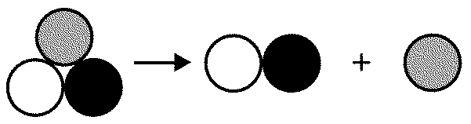 ___________________________________________
4.  ________________________________

**Answer the questions below about types of reactions.**

1. How do you know if a chemical reaction has occurred?
2. Circle the reactants and put a triangle around the reactants.

2Al + 3CuCl2 → 2AlCl3 + 3Cu

1. If you start out with only one reactant, what kind of reaction will it be?
2. If you end up with only one product, what kind of reaction will it be?
3. If you have two compounds that react with each other to produce two new compounds, what kind of reaction will it be?
4. If you have a metal and a compound and they react to produce a new compound and a new metal, what kind of reaction will it be?
5. If you have CO2 and H2O as your products, what kind of reaction will it be?
6. If you have a reaction that needs heat to start reacting, is it endothermic or exothermic?
7. If you have a reaction that produces heat, is it endothermic or exothermic?