Name______________________________________________Period_____Date___________

Chapter 5: Soil Homework

- List the four major components of soil.

- How does climate affect soil formation?

- Describe the major characteristics of the A, B, and C horizons.

- What factor has the greatest affect on soil formation?

- True or False: the longer a soil has been forming, the thinner it becomes.

- What are the three main types of soils and in what climates are they typically found?

- What type of soil is most likely found in New Mexico?

- What does the term “parent material” mean in referring to soil formation?

- What soil texture best supports plant life?

- A gardener notices that rain showers usually produce long-lasting puddles in her garden. Is it more likely that the soil contains too much sand or too much clay? Explain.

Use the chart below to answer questions 11&12

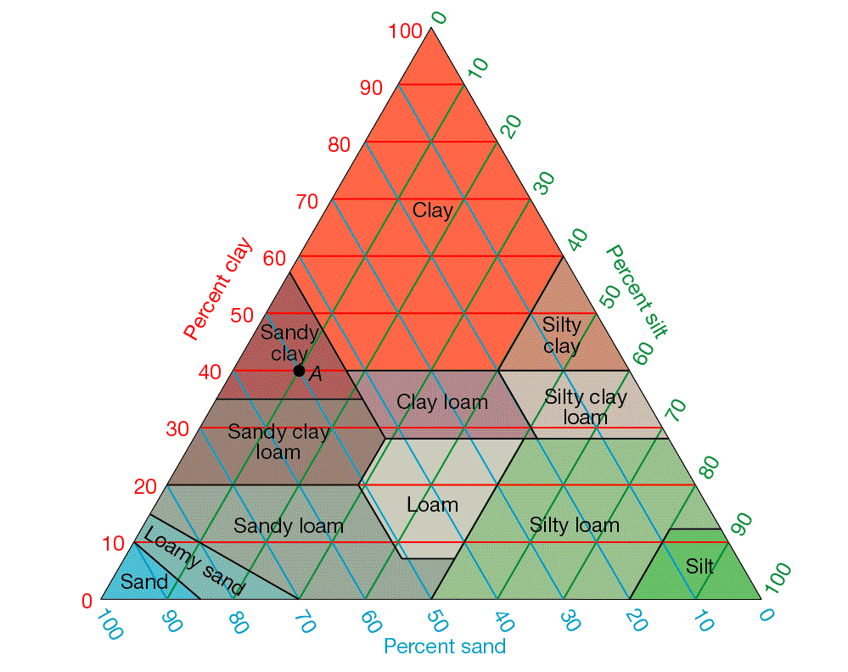
X

- The name given to soil that contains 60% clay, 20% silt, and 20% sand is:

- What are the percentages of clay, slit, and sand in the soil at the point labeled X?

