SOLUBILITY CHART
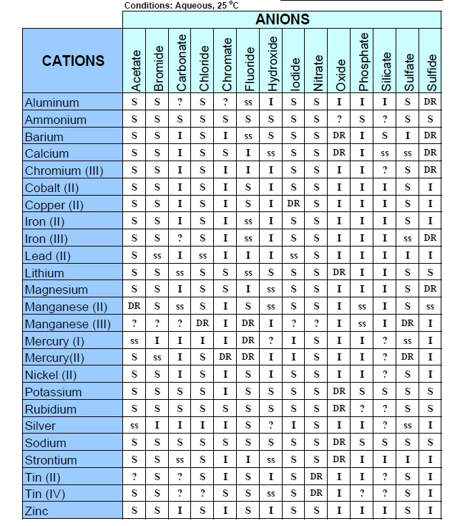

S= Soluble I=Insoluble ss = slightly soluble DR=reacts with water ?=doesn’t form/no info

