Name__________________________________________________Period_______Date_____________

Physical Science-
Part I: Sound

Sound
- What is sound?
- Sound is really tiny fluctuations of _____________________________
- Remember, sound waves are _________________________ waves
  - Particles of air vibrate in the __________ direction as the wave travel
- Why is sound longitudinal?
- Waves in air can’t really be transverse because the atoms/molecules are ______________________ to each other
- Air molecules can only _________________________one another
- Speed of Sound Depends on:
  - ___________________________ of medium
    - Travels _____________ at ________________ temperatures
  - Type of ____________________________________
    - Travels better through _________________________________
    - Can’t travel through a __________________________
    - _____________ have faster speeds because atoms are hooked up by _________________________________
- Human Hearing:
  - Sequence of events: ________________________________________________ ________________________________________________________________________________________________________________________________________
  - Ear ignores changes ___________________________________
  - Ear can’t be wiggled faster than about ______________________________
- _________________
  - __________________________________________ of a sound
  - Depends on __________________________ of sound wave

- ______________________
  - __________________ of a sound
  - Depends on ______________________(____________________) of sound
  - Measured in _________________________________
  - ___________________ is equivalent to ______________________
- Humans hear sounds in a limited __________________________ range
  - Human range: __________________________________
  - Any sound ________________ the human range of hearing is known as an _________________________
  - Any sound _____________________ the human range of hearing is known as an _______________________________
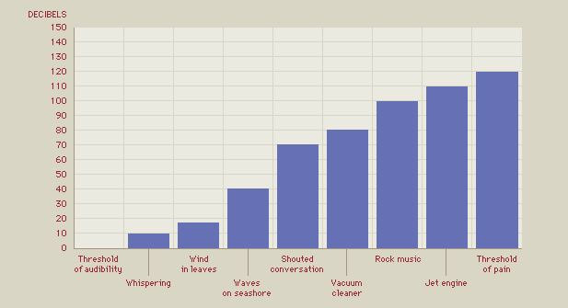

- Interaction of Sound Waves
- Reflection: When sound encounters an ____________________ the sound waves _________________________________. This causes an ______________.
- Refraction: Sound waves can ___________ if there are different ____________________ in the ___________________. The wave always bends _________________________________ temperatures
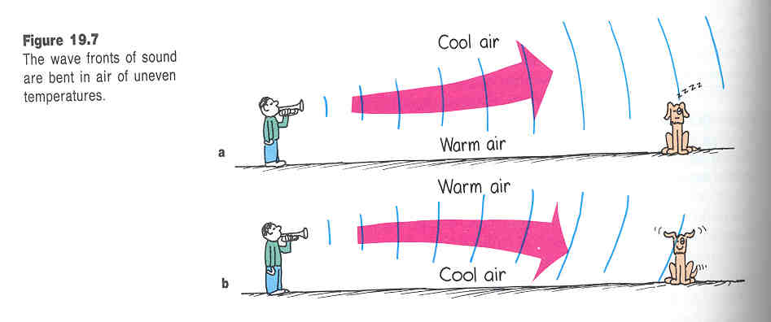
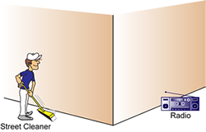
- Diffraction: since sound diffracts, we can hear sounds ____________________ ____________________________________________________

- ____________________________
  - Caused by a change in _______________________________ caused by a ________________________ source
    - Moving towards you pitch sounds _________________
    - Moving away from you pitch sounds ________________
    - Stationary (________________________) source: same frequency in ________________________
    - _________________________source: waves _________________ to produce a ____________________________________________________
- Music
- Music
  - _______________________________________________________________
  - _______________________________
- Noise
  - _________________________________________________________________
- __________________________________
  - When one vibrating object forces another object to vibrate at the __________ frequency
  - Results in a ______________ sound because a greater ________________________________ is vibrating
  - Used in guitars, pianos, etc.
- ______________________
  - A phenomenon that occurs when ________ objects naturally vibrate at the _________________ frequency
  - Special case of ________________________________
  - Object is induced to vibrate at its ___________________________________
- Harmonics
  - ____________________________ Harmonics:
    - The ___________________ natural frequency of an object
  - __________________
    - _______________________ of the fundamental frequency
- Interference
  - Ability of two or more waves to _____________________ to form a ____________________________
  - Constructive: sound gets _________________________
  - Destructive: sound gets __________________________
- Beats
  - _______________ in sound _______________ produced by two slightly ________________ frequencies
  - Both _____________________________________________ interference occur

- Beats and average frequency:

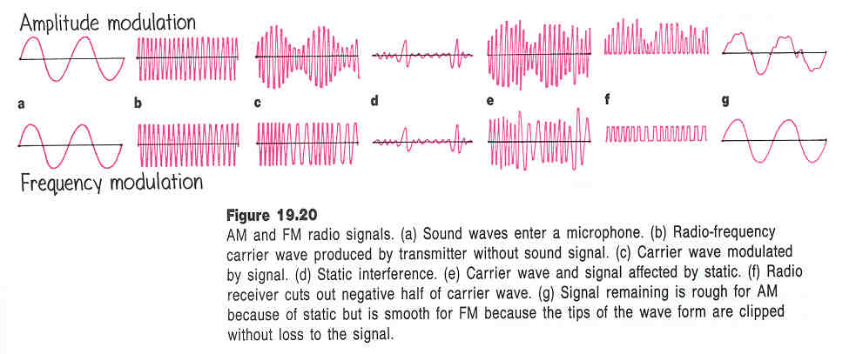
- ___________________________: the study of sound
- _______________________________: ____________________________ produced by the ________________________________ of sound

