Name____________________________________________Period_______Date__________________

Motion Graphs Practice

Part I: Matching Speed Graphs

- The object left the starting position at a constant speed, stopped in the middle, and then returned to the starting position
- The object is not moving
- The object’s speed is increasing
- The object’s speed is constant and traveling away from the starting position.
- The object’s left the starting position at a constant speed, stopped in the middle, and then continued moving farther away.
- The object’s speed is decreasing
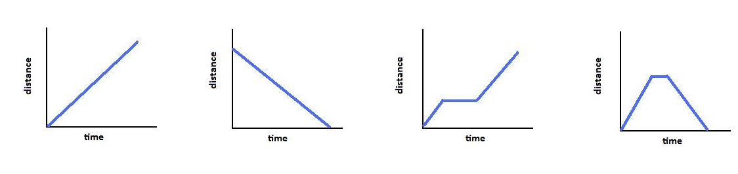
- The object’s speed is constant and traveling towards the 0 distance mark

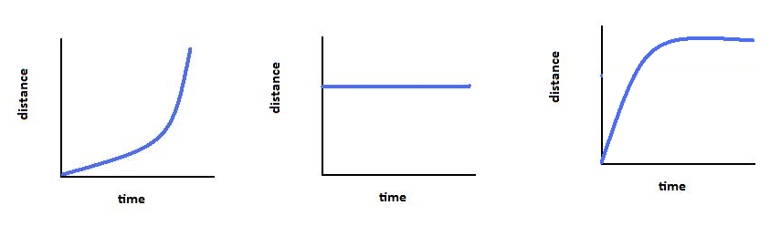
______ ______ ______ ______

_______ _______ _______

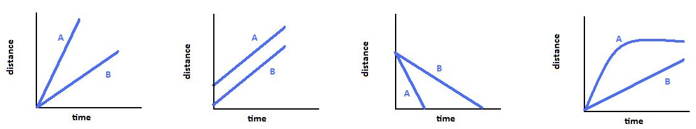
Which of the following graphs represents 2 objects traveling at the same speed?

A B C D
Part II: Matching Acceleration Graphs

- The object is not moving
- The object starts at a constant speed and then decelerates, slowing down
- The object has a constant speed
- The object speeds up, reaches a constant speed, and then slows down
- The object is speeding up, it has acceleration
- The object starts at a constant speed and then accelerates, speeding up
- The object is slowing down, it has deceleration
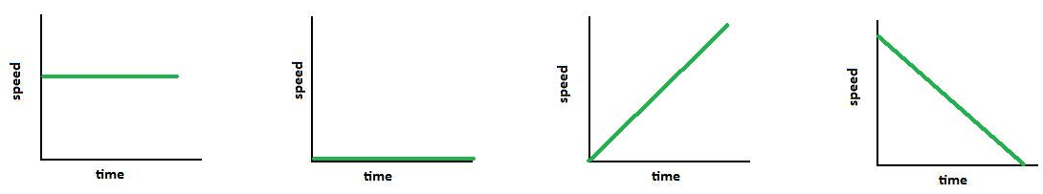
- The object slows down, stops, and then speeds back up

______ ______ ______ ______
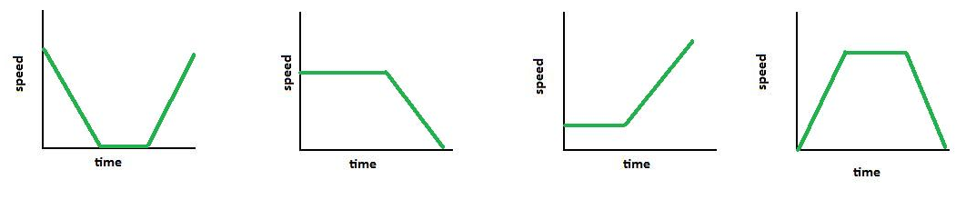

______ ______ ______ ______

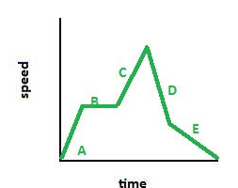
Describe what is happening at each point on the graph below:

A: ______________________________________________

B: _______________________________________________

C: _______________________________________________

D: _______________________________________________

E: _______________________________________________

