Honors Chemistry II
Summer Assignment

Students: Use your notes packet to help you with the problems as needed. If you get stuck, you can always email Mrs. Ellis at julia_ellis@bsin.k12.nm.us

THIS ASSIGNMENT IS DUE THE FIRST DAY OF SCHOOL!!!!! DO NOT WAIT TO THE LAST MINUTE TO BEGIN. SHOW WORK!

Sig Figs, Metrics, Dimensional Analysis
- How many significant figures in each of the following?

  - 1.92
  - 0.030100
  - 6.022 x 10²²
  - 460.00
  - 0.00036
  - 100
  - 1001
  - 1010
  - 0.0001
  - 0.0202

- Calculate the following to the correct number of significant figures. (REMEMBER, if you are having trouble using the correct sig figs, try using scientific notation to help)

  - 1.27 g / 5.296 cm³
  - 12.235 g / 1.01 L
  - 12.2 g + 0.38 g
  - 17.3 + 23
  - 2.1 x 3.21
  - 200.1 x 120
  - 17.6 + 2.838 + 2.3 + 110.77

- Complete the following using dimensional analysis (SHOW WORK)
  - 515 m = __________ miles
  - 200. in = __________ meters
  - 325 days = _______________seconds
  - 3 meters in centimeters
  - 10 kilometers into meters
  - 3264 microliters into liters
  - 8.176 x 10⁸⁷ seconds into decades
  - 350 ft² into cm²

- Use dimensional analysis for the following problem: A furlong is a unit used in horse racing, and the units chain and link are used in land surveying. There are 8 furlongs in a mile, 10 chains in a furlong, and 100 links in a chain. Calculate the length of 1 link in inches. (SHOW WORK)

- Use dimensional analysis: How many miles could you drive for $7.90 if the gas mileage of your car is 14 km/liter of gas and the price of gas is $2.64 gallon? (1 km= 0.62 mi; 4 qt/gallon, 1.1 qt/L)

Atom & Periodic Table
- Calculate the appropriate quantity in the chart below:
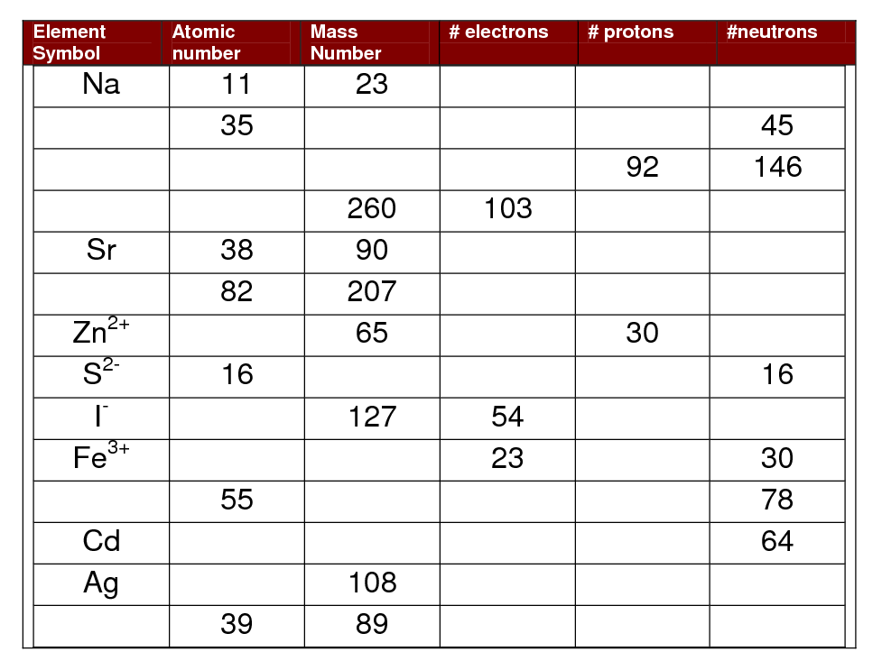
- What does a period tell you about an atom? What does a group tell you about an atom?

- In the following, rank the atoms from smallest to largest atomic radius:
  - O, F, N
  - K, Rb, Na
  - K, Ca, Mg
  - Br, As, S
  - Si, C, N
  - Na+, Na
  - Cl, Cl⁻¹
  - Be⁺², Na⁺¹, Ne
  - N⁻³, O⁻², F⁻¹, Ne

- In the following, answer which has the lowest ionization energy:
  - Rb, K, Cs
  - O, F, N
  - K, Na, Rb
  - K, Ca, Mg
  - B, N, C

- Give the full electron configuration and the noble gas short hand configuration of the atoms below:
 | Full | Shorthand
Si
Br
V
Ag
Rb

Nomenclature
- Write formulas for the following substances:

a. Barium sulfate ___________________
b. Ammonium chloride ______________
c. Chlorine monoxide ________________
d. Silicone tetrachloride _____________
e. Magnesium fluoride _______________
f. Sodium oxide ____________________
g. Sodium peroxide__________________
h. Copper (I) iodide _________________
i. Zinc sulfide ______________________
j. Potassium carbonate ______________
k. Hydrobromic acid ________________
l. Perchloric acid ___________________
m. Lead (II) acetate ________________
n. Sodium permanganate ____________
o. Lithium oxalate __________________
p. Potassium cyanide ________________
q. Iron (III) hydroxide _______________
r. Silicon dioxide __________________
s. Nitrogen trifluoride ______________
t. Chromium (III) oxide ______________
u. Calcium chlorate _________________
v. Sodium thiocyanate _______________
w. Cobalt (III) nitrate _______________
x. Nitrous acid _____________________
y. Ammonium phosphate ____________
z. Potassium chromate ______________

- Name each of the following compounds (don’t forget about acids)

a. CuSO₄ _______________________
b. PCl₃ _________________________
c. Li₃N _________________________
d. BaSO₃ _______________________
e. N₂F₄ _________________________
f. KClO₄ ________________________
g. NaH _________________________
h. (NH₄)₂Cr₂O₇ ___________________
i. HNO₂ ________________________
j. Sr₃P₂ _________________________
k. Mg(OH)₂ ______________________
l. Al₂S₃ _________________________
m. AgBr _______________________
n. P₄O₁₀ ________________________
o. HC₂H₃O₂ ______________________
p. CaI₂ _________________________
q. MnO₂ _______________________
r. Li₂O _________________________
s. FeI₃ _________________________
t. Cu₃PO₄ _______________________
u. PCl₃ _________________________
v. NaCN ________________________
w. Cs₃N ________________________
x. Zn(NO₃)₂ _____________________
y. N₂O _________________________

Rxn Stuff/Solubility

- Write the balance equation for the following. Identify the type of reaction as synthesis, decomposition, single replacement, double replacement, combustion

  - Magnesium + oxygen → magnesium oxide Type:
  - Iron + sulfur → iron (III) sulfide Type:
  - Sulfur dioxide + water → sulfurous acid Type:
  - Dinitrogen pentoxide + water → nitric acid Type:
  - Potassium oxide + water → potassium hydroxide Type:
  - Ammonia + phosphoric acid → ammonium phosphate Type:
  - Sodium chloride → sodium + Chlorine Type:
  - Strontium bromide → strontium + bromine Type:
  - Potassium chlorate → potassium chloride + oxygen Type:
  - Copper (II) bromate → copper (II) bromide + oxygen Type:
  - Sodium iodide + lead (IV) sulfate → lead (IV) iodide + sodium sulfate Type:
  - Nitric acid + magnesium hydroxide → water + magnesium nitrate Type:
  - Methane (CH₄) + oxygen → carbon dioxide + water Type:
  - Ethanol ( C₂H₅OH) + oxygen → carbon dioxide + water Type:
  - Butanol (C₄H₉OH) + oxygen → carbon dioxide + water Type:

- Determine the precipitate in the following reactions:

silver I nitrate + iron II chloride ______________
lead II nitrate + potassium iodide ______________
lead II nitrate + iron II chloride ______________
silver I nitrate + potassium iodide ______________
silver I nitrate + sodium hydroxide ______________
magnesium sulfate + sodium carbonate ______________
copper II sulfate + sodium hydroxide ______________
sodium carbonate + silver I nitrate ______________
copper II sulfate + sodium phosphate ______________
silver I nitrate + sodium hydroxide ______________
copper II sulfate + sodium carbonate ______________
sodium phosphate + silver I nitrate ______________

Stoichiometry Stuff (SHOW WORK ON ALL!)
- Calculate the mass of O₂ produced if 2.50 g of KClO₃ are completely decomposed by heating. KClO₃ → KCl + O₂

- Determine the number of molecules in 2.23 mol of nitrogen molecules (N₂)

- What is the empirical formula of a compound that contains 53.73% Fe & 46.27% S?

- Calculate the molecular formula of a compound if its empirical formula is C₃H₇ and it has a molecular mass of 129 g/mole

- White gold is an alloy that typically contains 60.0% by mass gold and the remainder is platinum. If 175 g of gold are available, how many grams of Pt are required to combine with the gold to form this alloy?

- A hydrated compound has 18.29% Ca, 32.37% Cl, and 49.34 % water. What is this hydrate’s formula?

- What mass of copper is required to replace silver for 4.00 grams of silver nitrate dissolved in water? (balance rxn first)

Cu(s) + AgNO₃ → Cu(NO₃)₂ + Ag

- The molecular formula of morphine is C₁₇H₁₉NO₃
  - Calculate the molar mass.

  - What fraction of atoms is carbon?

  - Which element contributes least to the molar mass?

- Calcium carbonate decomposes upon heating, producing calcium oxide and carbon dioxide gas.
  - Write a balanced chemical equation for this reaction.

  - How many grams of calcium oxide will be produced after 12.25 g of calcium carbonate is completely decomposed?

  - What volume of carbon dioxide gas is produced from this amount of calcium carbonate at STP? (22.4 L =1 mole for gases)

- Hydrogen gas and bromine gas react to from hydrogen bromide gas.
  - Write a balanced chemical equation for this reaction.

  - 3.2 g of hydrogen gas and 9.5 g of bromine gas react. Which is the limiting reactant?

  - How many grams of excess reactant will be left unreacted?

  - What volume of HBr, measured at STP, is produced in b?

- When ammonia gas (NH₃), oxygen gas, and methane gas (CH₄) are combined, the products are hydrogen cyanide gas and water.
  - Write a balanced chemical equation for this reaction

  - Calculate the mass of each produce produced with 225 g of oxygen is reacted with an excess of the other 2 reactants.

  - If the actual yield of the experiment is 105 g of HCN, calculate the percent yield.

- When solutions of potassium iodide and lead (II) nitrate are combined, the products are potassium nitrate and bright yellow lead (II) iodide.
  - Write a balance equation for this reaction, including (aq) and (s)

  - Calculate the mass of precipitate produced with 50.0 mL of 0.45 M potassium iodide solution and 75 mL of 0.55 M lead (II) nitrate solution are mixed.

  - Calculate the volume of 0.50 M potassium iodide required to react completely with 50.0 mL of 0.50 M lead (II) nitrate

Acids & Bases / Oxidation #s
- List the following (you should have these memorized)
  - Strong acids-
  - Strong bases-
- Give the common monatomic ion charge for the following representative elements:

  - B
  - Br
  - Si
  - K
  - Se
  - Ba

- Determine the oxidation state of the underlined element in each of the following:

  - P₄
  - Os⁸⁺
  - OF₂
  - CH₃OH
  - H₂O₂
  - MgH₂
  - H₂O
  - Cl₂
  - N³⁻
  - CaO₂
  - HClO
  - Na₂O₂
  - AlH₃
  - H₂S

- Determine the oxidation state of the underlined element (fractions or zeros are possible)

  - HNO₂
  - MnO₄²⁻
  - H₂CO
  - Fe₃O₄
  - H₄SiO₄
  - Cr₂O₇²⁻
  - H₂PtCl₂
  - Cr₄S₅

Make sure you are working on basic organic nomenclature!!!!

