**Honors Chemistry II (AP Chemistry)**

**Summer Review Notes**

***Students:*** *Beginning near the end of July, you will want to start these review concepts in order to prepare yourself for the rigor of the course. Please go over the notes below, and the complete the summer assignment. Answers will be posted on Mrs. Ellis’ website:* [*www.mrsellisscience.weebly.com*](http://www.mrsellisscience.weebly.com)

**TOPIC #1: Measurement Stuff**

**SIGNIFICANT FIGURES:**

Rules for counting sig figs are summarized below

1. All non-zeros are significant.
2. About zeros:
   1. Zeros in a “zero sandwich” are significant (both 4308 and 43.08 contain 4 sig figs)
   2. Trailing zeros are significant IF there is a decimal somewhere in the problem (42000=2 sig figs; 42000.0=6 sig figs; 0.87950=5 sig figs)
   3. Leading zeros are NOT significant (0.45=2 sig figs; 0.000032=2 sig figs)

Rules for sig figs in mathematical operations

1. Adding and subtracting: your answer depends on the number of decimal places. You can only have as many decimal places in your answer that your lowest decimal place had that you were trying to add or subtract
   1. 150.0 + 0.507 CAN ONLY HAVE 1 DECIMAL PLACE answer=150.5
   2. 25 + 8.434219 CAN HAVE 0 DECIMAL PLACE answer= 28
2. Multiplying and dividing: Your answer depends on the lowest number of sig figs in your original numbers. Does NOT depend on decimal places
   1. 32.5 x 23 CAN ONLY HAVE 2 sig figs

Rounding (just in case)

* For your masses of elements, I want you to use numbers to 2 decimal places
* Whatever you are trying to round to, look at the next decimal place to the right to tell you whether to round up or not
* Some rounding will be weird
  + - Carbon: 12.011=12.01
    - Fluorine: 18.999=19.00
    - Sulfur: 32.066=32.07
    - Potassium: 39.089=39.10
    - Magnesium: 24.304=24.31
    - Sodium: 22.989=22.99

**METRICS**

* Know the following 8 base units:

|  |  |  |  |  |  |  |  |
| --- | --- | --- | --- | --- | --- | --- | --- |
| Length | Meter (m) | Mass | Kilogram(kg) | Electric current | Ampere (A) | Volume | Liter (L) |
| Time | Second (s) | Temperature | Kelvin (K) and Celsius (◦C) | Amount of substance | Mole (mol) | Intensity | Candela (cd) |

* Prefixes

|  |  |  |
| --- | --- | --- |
| giga- (G-) | 109 | 1 billion |
| mega- (M-) | 106 | 1 million |
| kilo- (k-) | 103 | 1 thousand |
| hecto- (h-) | 102 | 1 hundred |
| deka- (da-) | 101 | Ten |
| BASE UNIT (no prefix) | 100 (=1) |  |
| deci- (d-) | 10-1 | 1 tenth |
| centi- (c-) | 10-2 | 1 hundredth |
| milli (m-) | 10-3 | 1 thousandth |
| micro- (μ-) | 10-6 | 1 millionth |
| nano- (n-) | 10-9 | 1 billionth |
| pico- (p-) | 10-12 | 1 trillionith |

* Use dimensional analysis to change between prefixes

DIMENSIONAL ANALYSIS

* You should be able to convert units of measure and complete stoichiometric calculations using dimensional analysis
* Use the internet as a resource if you do not remember how to do this

|  |  |  |  |
| --- | --- | --- | --- |
|  |  |  |  |
|  |  |  |  |
|  |  |  |  |

**TOPIC #2: ATOMIC STRUCTURE & PERIODIC TABLE**

**ATOMIC STRUCTURE**

Calculations:

|  |  |  |  |
| --- | --- | --- | --- |
| Mass # | # neutrons | #p | # electrons |
| Protons + Neutrons | Mass # - protons | Atomic # | = # p in a neutral atom  IF CHARGED:  if a – charge, add that many e-  if a + charge, subtract that many e- |

Isotopes: Atoms of the same element with different masses because different # neutrons

Cation: An ion with a POSITIVE CHARGE that has LOST electrons

Anion: An ion with a NEGATIVE CHARGE that has GAINED electrons

**ELECTRON CONFIGURATION:**

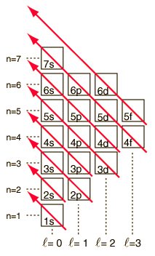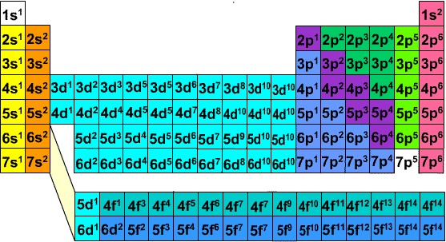

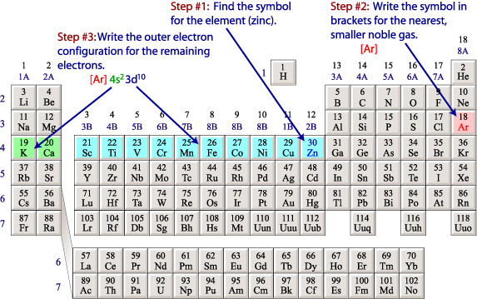

*Noble Gas Shorthand:*

**PERIODIC TABLE STUFF**

* Row = Period; Column= Group, Family
* Group IA= Alkali Metals; Group IIA= Alkaline Earth Metals; Group VIIA= Halogens, Group VIIIA= Noble Gases; Stair-Step Line= Metalloids
* Group A= Main Group Elements; Group B = Transition Metals

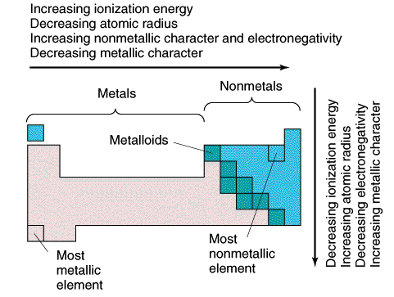

**PERIODIC TABLE TRENDS**

* Ionization Energy: energy required

to remove the least tightly bound

electron

* Electron Affinity: energy change that

occurs when an electron is added to

an atom

* CATIONS are SMALLER than the

atoms from which they are formed

* ANIONS are LARGER than the

atoms from which they are formed

* ISOELECTRONIC: the larger the nuclear

charge (# of protons) the smaller the radius

**TOPIC #3: NAMING, BONDING, & REACTIONS OF COMPOUNDS**

**Ionic Compounds (Metal + Nonmetal, Cation + Anion)**

*Rules for Ionic Formulas*

1. Cross cation and anion charges to find subscripts
2. Do NOT write 1s
3. Reduce subscripts to lowest terms
   1. Example 1: Ca+2 Cl-1 → CaCl2
   2. Example 2: Ca+2 O-2 → Ca2O2 → CaO
   3. Example 3: Fe+3 (NO3)-1 → Fe(NO3)3
   4. Example 4: Ni+2 (CO3)-2 → Ni2(CO3)2 → Ni(CO3)

*Rules for Naming Binary Ionic*

1. If NOT a transition metal = METAL NAME + ANION NAME, change ending to –ide
   1. EXAMPLE: MgCl2 = Magnesium Chloride
2. If a transition metal =

METAL NAME (ROM NUM TO FOR CHARGE) + anion name, change ending to –ide

* 1. EXAMPLE= CuCl3 + Copper (III) Chloride ; MnO = Manganese (II) Oxide
     1. To find charge, uncross your charges-be sure to start with anion’s charge first to make sure the formula was not reduced like in second example
  2. Exceptions: Ag is always +1, Zn is always +2 (there are a few others, but these are most important) so they do not need roman numerals

*Rules for Naming Ternary Ionic*

1. If NOT a transition metal = METAL NAME + POLYATOMIC ION NAME
   1. EXAMPLE: Mg(ClO3)2 = Magnesium Chlorate
2. If a transition metal =

METAL NAME (ROM NUM TO FOR CHARGE) + POLYATOMIC ION NAME

* 1. EXAMPLE= CuSO4 + Copper (II) Sulfate ; Co2(CO3)3 = Cobalt (III) Carbonate
     1. To find charge, uncross your charges-be sure to start with anion’s charge first to make sure the formula was not reduced like in second example
  2. Exceptions: Ag is always +1, Zn is always +2 (there are a few others, but these are most important) so they do not need roman numerals

**Covalent Compounds (NONMETAL + NONMETAL)**

*Rules for Covalent Formulas:*

1. Use prefixes to describe how many of each atom
2. DO NOT USE PREFIX IF:
   1. It’s the first element and only one
   2. If it is a Br2I2N2Cl2H2H2O2F2
3. EXAMPLE:
   1. Dinitrogen monoxide = N2O
   2. Nitrogen monoxide = NO
   3. Nitrogen = N2
   4. Dinitrogen pentaoxide= N2O5

*Rules for Covalent Naming:*

1. Use subscripts to find prefix to use
2. DO NOT USE PREFIXES IF:
   1. It’s the first element and only one
   2. If it’s a Br2I2N2Cl2H2H2O2F2 name it as appears on PT
3. EXAMPLE:
   1. P2O5= diphosphorus pentoxide
   2. CO2= carbon dioxide
   3. Cl2= chlorine

|  |  |  |  |
| --- | --- | --- | --- |
| 1 | Mono- | 6 | Hexa- |
| 2 | Di- | 7 | Hepta- |
| 3 | Tri- | 8 | Octa- |
| 4 | Tetra- | 9 | Nona- |
| 5 | Penta- | 10 | Deca- |

* 1. IF= iodine monofluoride

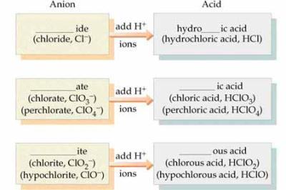**Naming Acids:**

*Binary Acids: PREFIX-STEM-SUFFIX ACID*

Hydro________________ic Acid

Ex. HCl = Hydrochloric Acid

*Ternary Acids: Use polyatomic ending to help you!*

* If it ends in “ate” change the ending to “ic”
* If it ends it “ite” change the ending to “ous”
* If it has a “per” prefix add it before hydro and change ending to “ic”
* If it has a “hypo” prefix add it before hydro and change ending to “ous”

**Bonding Basics Chart**

**Relative strength: Stronger Weaker**

|  |  |  |  |
| --- | --- | --- | --- |
|  | **COVALENT** | **IONIC** | **METALLIC** |
| **What makes the bond?** | Nonmetal + nonmetal | Metal + non metal | Metal + metal |
| **What are the electrons doing?** | Sharing | Transferring | Moving between atom to atom |
| **Physical State?** | Any (solid, liquid, gas) | Solid | Solid |
| **Melting Point?** | Low | High | Very High |
| **Soluble in water?** | Not usually | Yes | No |
| **Conducts Electricity?** | No | Yes, in solution | Yes |
| **Other properties?** | Odorous | Brittle | Malleable, lustrous |

ONLY VALENCE ELECTRONS PARTICIPATE IN BONDING!

Why do things bond?

1. To become more stable and to fill their outer shell to be more like the noble gases
2. Becoming more stable decreases the potential energy

*Other things you should be able to find:*

* *% Composition of a Compound*
* Example: find the % composition in the compound C2H6
  + Find the molar mass of C2H6 = 30.08
  + Use dim. Analysis to find % C & % H
  + %C =(2 mole C) x(12.01 g C/1 mole C)=24.02 g C,(24.02/33.08)x100 =79.85% C

**TYPES OF REACTIONS**

*Classifying Reaction Types*

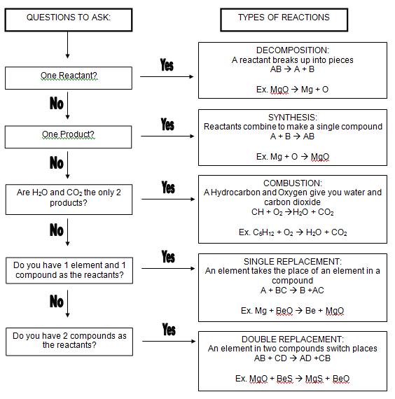

*STEPS FOR BALANCING*



**TOPIC #4: STOICHIOMETRY, Empirical & Molecular Formulas**

*Steps for Stoich Rxns:*

1. Write and balance the chemical reaction
2. Identify what is given in the problem and write it down!
3. Convert into moles
4. Set up a molar ratio
5. Convert moles to whatever is needed is next

*Limiting Reactants*

* Repeat steps 2-5 with given values
* Whichever number produces the smallest is the limiting reactant

*Amount of excess material:*

Given amount of LR 1 mole LR Coeffeicient of Excess (MM) g excess

MM (g) of LR Coefficient of LR 1 mole Excess

*Percent Yield*

= (experimental yield/theoretical yield) x 100

* Experimental=what was made inlab
* Theoretical=what you calculated from stoich problem

*Empirical and Molecular Formula Steps*



**Basic Acid & Base**

* Acid= H+ donor ; Base=H+ receiver
* pH <7 = Acid, pH>7=base, pH=7-neutral
* Strong Acids:

|  |  |  |  |
| --- | --- | --- | --- |
| HCl | HNO3 | H2SO4 | HBr |
| HI | HClO3 | HClO4 |  |

* Strong Bases:

|  |  |  |  |  |
| --- | --- | --- | --- | --- |
| LiOH | NaOH | KOH | RbOH |  |
| RbOH | CsOH | Ca(OH)2 | Sr(OH)2 | Ba(OH)2 |

* pH= -log[H+] pOH= -log[OH-] pH + pOH = 14

**SOLUBILITY RULES (will have to memorize these)**

*Soluble Compounds*

1. All compounds of the alkali metals (group 1) are soluble
2. All salts containing NH4+, NO3-, ClO4-, ClO3-, C2H3O­2­ are soluble
3. All chlorides, bromides, and iodides are soluble except those of Ag+, Pb+2, Hg2+2
4. All sulfates are soluble except those of Ag+, Pb+2, Ca+2, Sr+2, Hg2+2, Ba+2

*Insoluble Compounds*

1. All hydroxides are in soluble except those of Group I, NH4+, Ca+2, Sr+2, Ba+2
2. All salts containing phosphate, carbonate, sulfite, and sulfide are soluble except those of Group I and NH4+1

**Assigning OXIDATION #s**

1. The convention is that the cation is written first in a formula followed by the anion
2. The oxidation of a free element is always zero
   1. He and N2 have oxidation numbers of 0
3. The oxidation number of a monatomic ion equals the charge of the ion
   1. Na+is +1, N-3 is -3
4. The usual oxidation number for Hydrogen is +1
   1. Except in compounds containing elements that are less electronegative than H, like in CaH2­
5. The usual oxidation number of Oxygen is -2
   1. Exceptions include OF2, since F is more electronegative than O, and BaO2 due to the structure of the peroxide ion with is O-O-2
6. The oxidation of a Group IA element in a compound +1
7. The oxidation of a Group IIA element in a compound is +2
8. The oxidation of a Group VIIA element in a compound -1, except when that element is combined with one having a higher electronegativity
   1. Cl is -1 in HCl, but Cl is +1 in HOCl
9. The sum of the oxidation numbers of all the atoms in a neutral compound is 0
10. The sum of the oxidation numbers in a polyatomic ion is equal to the charge of the ion
    1. Ex, the sum of the oxidation numbers in the sulfate ion is -2

NEW: BASIC ORGANIC NOMENCLATURE

You should be able to provide the name and formulas for basic Alkanes, Alkenes, Alkynes, Alcohols, & carboxylic acids

|  |  |  |  |
| --- | --- | --- | --- |
| # C | Prefix | #C | Prefix |
| 1 | Meth- | 6 | Hex- |
| 2 | Eth- | 7 | Hept- |
| 3 | Prop- | 8 | Oct- |
| 4 | But- | 9 | Non- |
| 5 | Pent- | 10 | Dec- |

**Alkanes: CnH2n+2 these compounds end in –ane** (all C-C single bonds)

**Alkene: CnH2n  these compounds end in –ene** (at least one double C=C bond)

**Alkyne: CnH2n-2  these compounds end in –yne** (at least one triple C≡C bond)

*Examples*: Methane (CH4), Propene (C3H6), butyne (C4H6)

**Alcohol: CnH2n+1OH**

alkanes with one of the –H bonds to C changes to a –OH bond

*Examples:* methanol (CH3OH), hexanol (C6H13OH)

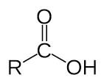

**Carboxylic Acid: CnH2nO2 but we will write the end as COOH**

*Examples:* methanoic acid (formic acid): CH2O2 write as…CHCOOH

ethanoic acid (acetic acid); C2H4O2 write as… CH3COOH

pentanoic acid; C5H10O2 write as…. C4H9COOH