Name__________________________________________________ Period_________

TLC Chromatography Lab & Food Dyes

Objective:

The technique of thin-layer chromatography (TLC) will be applied to investigate water soluble food dyes. The TLC plates to be used consist of a thin layer of solid silica gel coated onto a flexible plastic material. In this lab you will create a standard table for the 7 FD&C dyes and compare these values to evaluate which are present in food coloring.

Background:

Imagine! The entire palette of artificial food colors is derived from just seven dyes certified by the Food & Drug Administration for use in foods, drugs, and cosmetics (FD&C). On the next page, are the names and structures of these seven dyes. We will be studying these dyes with a method known as Thin-Layer Chromatography (TLC). We will also be looking at commercial food coloring packs with red, yellow, blue, and green coloring.

TLC is much more effective than paper chromatography because the more uniform particles used generally make results more reproducible. Below are some terms you should be familiar with:

- Solvent: a solvent is a liquid that you can dissolve a chemical in.
- Stationary Phase: to separate chemicals, we have to have a platform on which to separate them. In our case, the platform is a TLC plate which is made of a silica gel. The plate will not move throughout the chromatography experiment.
- Mobile phase: a mobile phase is the solvent that carries the chemicals through the stationary phase. Chemicals don’t move on the TLC plate alone, but if we add a solvent, it can draw the chemicals up through the paper. Our mobile phase will be a 4:1 mixture of isopropanol and concentrated ammonia.
- Retention factor (Rf)-the distance our chemicals move during chromatography is typically less than the distance the mobile phase moves. We can measure the distance by using the Rf value. This is the distance a chemical moves on our TLC plate during the separating divided by the distance the mobile phase moves.
Rf = $\frac{distance solute travels}{distance solvent travels}$
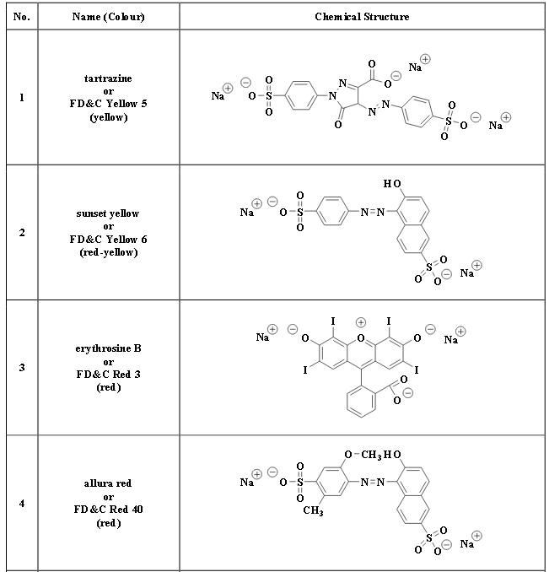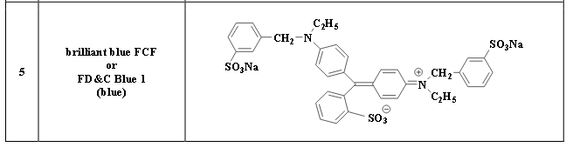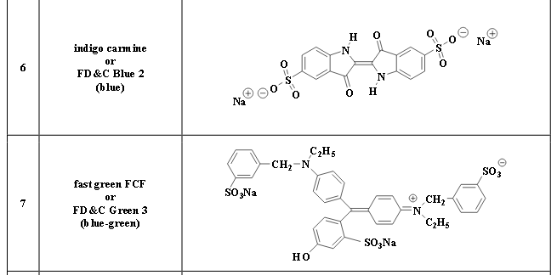

Materials:
- 4 glass jars with lids
- 5 TLC plates
- forceps
- Pencil
- Ruler
- Capillary tubes (or toothpicks)
- FD&C Dyes
- Pack of Food Coloring
- Solvent System: 4:1 isopropanol : concentrated ammonia

Procedure:

- Practice your TLC plate spotting on 1 TLC plate with capillary tubes (or toothpicks). Be sure not to cross contaminate your tubes in this experiment. Your spot should be small and concentrated. Also try lightly drawing a pencil line on the silica plate without damaging the chromatography layer
- Each lab group will be collecting data for all 11 dyes to be tested. We will compile data as a class at the end of lab.
- Make a plan of how you will spot your plates. You have 4 plates to get 11 spots. Your spots should be at least 1 cm apart. (leave extra room on the edges) Draw your plan below:

- Describe the color of each of the food dye solutions in Table 1.
- Using the line method with a pencil, draw an origin line about 1 cm from what the bottom edge of each TLC plate will be.
- Carefully spot your 11 dots per your plan. The spots should be no more than 2 mm in diameter!
- Dry your spots by blowing hot air on it.
- Spot again using the same spots. Be VERY careful.
- Dry your spots again.
- Record a description of the color of each of the dried spots in Table 1.
- Mrs. Ellis will place a shallow layer of the chromatography solvent (no more than 0.5 cm) into each of your chromatography chambers. Do not open the jar until absolutely necessary.
- Check to make ensure no part of any of the sample spots will be below the surface of the solvent when the plate is inserted.
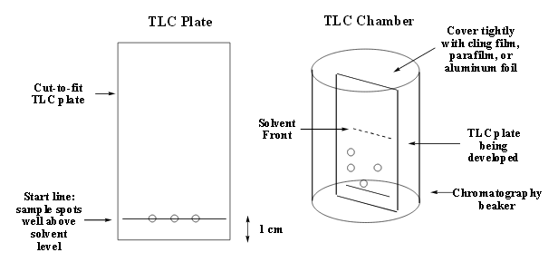
- One beaker at a time, take of the jar lid, and carefully place your TLC plate inside. It is okay to lean it against the sides of the jar. Tightly close the lids.
- Do not disturb the chambers during the development process.
- Allow the development to proceed for at least 30 min. Be sure to check the progress every 5 minutes or so. Do not allow the solvent front to move within 1 cm from the top edge of the plate or you will NOT be able to complete your calculations.
- When the development is complete, carefully take off the jar lid and remove the TLC plates and place on a dry paper towel.
- IMMEDIATELY mark the solvent front position with your pencil.
- Allow the solvent to evaporate from the TLC plates.
- While the solvent is evaporating, dispose of the solvent down the sink with water.
- Draw a description below of each chromatogram showing location, size, color of all spots on each plate.

- Mark the position of the centers of all the colored spots on the TLC plates.
- Measure the distance from the origin line and the solvent front and record it below:
__________________
- Measure the distance from the origin line to the center of all the colored spots. Record all the measured distance in table 1.
- Calculate the Rf values of all spots.
- Add data to class excel spreadsheet.

Table 1
 | Solution Color | Dried Spot Color | Distance solute traveled | Distance solvent traveled | Rf value
FD&C Yellow 5
FD&C Yellow 6
FD&C
Red 3
FD&C
Red 40
FD&C
Blue 1
FD&C
Blue 2
FD&C Green 3
Yellow
Food Coloring
Red
Food Coloring
Blue
Food Coloring
Green
Food Coloring

Questions:
- Why is it important to have the jar closed during the development of the TLC plate?

- Why do you think the different FD&C values different? What do you think controls the Rf value?

- Predict which FD&C values are in each of the food coloring colors.

- Why does green food coloring not contain FD&C Green 3? Make a prediction.

