Name_______________________________________Period_____Date_______________

Geology Unit 10 Guided Notes
Maps

Text Reference: Ch 1 pg 11-16

Representing Earth’s Surface
- Latitude and longitude are lines on the globe that are used to determine location
- ____________________is the distance ____________________ of the equator measured in _____________. Lines run _____________________________
- ____________________is the distance ____________________ of the Prime Meridian measured in _____________. Lines run _____________________________

Maps and Mapmaking
- No matter what kind of map is made, some portion of the surface will always look either too small, too big, or out of place. Mapmakers have, however, found ways to limit the distortion of shape, size, distance and direction.
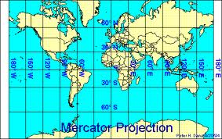
Types of Maps
- __________________________________________
  - _______________________________________
  - _______________________________________
  - ______________________________________
  - ______________________________________

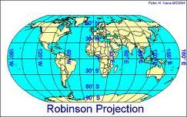
- _______________________________________
  - One of the most widely used
  - ______________________________________
________________________________________
  - ______________________________________
_________________________________________

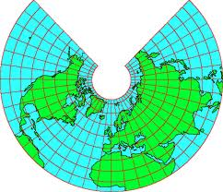
- __________________________________________
  - ___________________________________________
___________________________________________
___________________________________________
  - ___________________________________________
  - ___________________________________________
___________________________________________
  - ____________________________________________
  - _________________________________________________________________

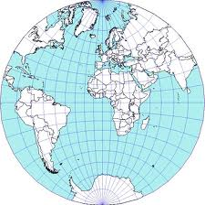
- __________________________________________
  - ___________________________________________
___________________________________________
___________________________________________
  - ___________________________________________
___________________________________________
  - ____________________________________________
_________________________________________________________________
____________________________________________

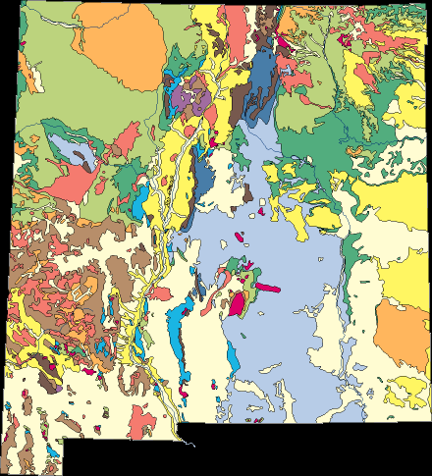
- _______________________________________
  - ______________________________________
________________________________________
  - ______________________________________
  - _______________________________________

TOPOGRAPHIC MAPS!

Topographic Map Basics
- In contrast to most maps, topographic maps show the _____________ of the Earth’s surface by using __________________________________________
- _______________=_______________________________________________________________________________________________
- _________________________=lines on a topographic map that indicate an __________
  - The _____________ the lines, the ___________ the slope
  - Contour lines ___________________________________________________
- ______________________=________________________________________________________________________________________
- _________________=_________________________________________________
- ___________________________________=_______________ that are labeled to help you find the _______________________
- A ________________________ is the ________________________ in ___________ between _____________contour lines that are ____________________________
  - Remember a contour interval is not the distance between the two lines, you need to use the _______________ to get that measurement

Topographic Map Features
- A ____________________, such as the inside of a dead volcano is represented by __________________ lines
- Hatchure lines are regular contour lines with __________________________sticking out from it
- The ___________ hachure line is at the _______________________ as the contour line before it

- Contour lines form ___________ that point _____________ when the cross a stream
- It is important to remember that they point in the ______________direction as the _________________________________
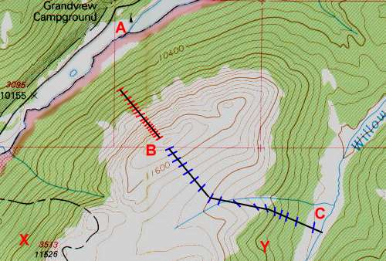

- Colors on the Map:
  - Blue lines/shapes:________________________________________
  - Brown:________________________________________________
  - Black:_________________________________________________
  - Green:________________________________________________
  - Red:__________________________________________________
Reading Topographic Maps
Steps
- First determine the ___________________________
- The determine the _________________________________
- Identify any _______________________________________________
- Use the _____________________________________________________________
- Look for areas where the contour lines are ________________________________
- Look for areas where the contour lines are _____________________________
Practice
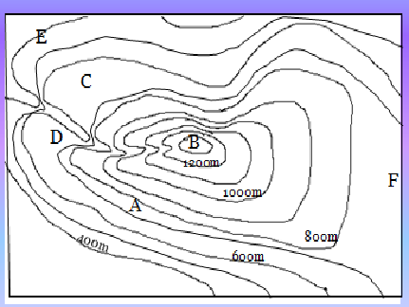
- Could the elevation at peak B be 1410 meters?

- What is the elevation at E?

- What is the elevation difference between A & B?

- Could the elevation at F be 417 meters?

- If you walked a straight line from D to C would you walk over a ridge or down a valley?

- Just looking at the map, would it be easier to head down from the peak going East or North?

