Name:_____________________________________Period_________Date__________
Geology-Unit 10 Review: Mapping
- Lines of latitude run_________________ (east/west, north/south) and are measured __________________(north/south, east/west) of the _______________(equator, prime meridian)

- Lines of longitude run_________________ (east/west, north/south) and are measured __________________(north/south, east/west) of the _______________(equator, prime meridian)

- True or False: All maps have some sort of distortion

- Describe the type of map listed below and its disadvantages and advantages
  - Mercator

  - Robinson

  - Conical

  - Gnomic

  - Geologic

  - Topographic

- Define Contour Index-

- Define Contour Line-

- Define Contour Interval-

- How would you know if an area is steep on a topographic map?

- True or False: Contour lines can cross
- Lines point the ____________(opposite, same) as the direction of water flow.

- What do the following colors/markings mean:
  - Hatchure marks:
  - Blue:
  - Brown:
  - Red:
  - Black:
  - Green:

- What is the contour interval on the map below? How many contour lines are there?

- Draw a contour map with at least 5 contours lines. Mark your contour indexes & the contour interval is 25 m. Your map should be steeper on one side.

- Match the latitude and longitude of the following cities using the map below:
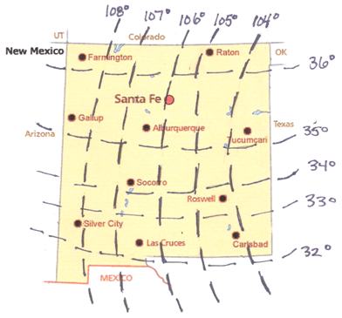
____Carlsbad
____Albuquerque
____Santa Fe
____Las Cruces

A. 35°37’N, 106°5’W
B. 32°20’N, 104°16’W
C. 35°3’N, 106°37’W
D. 32°18’N, 106°55’W

