Name_______________________________Period____Date_________

Physical Science Guided Notes
Scientific Method

Scientific Method
Scientific Inquiry
- Science assumes the natural world is_______________________________
- Goals of science are to:
  - ___________________________ in nature
  - Use the knowledge for ___________________________
- Science does ____________have to be done in a _____________________ ____________ or order but does need certain parts

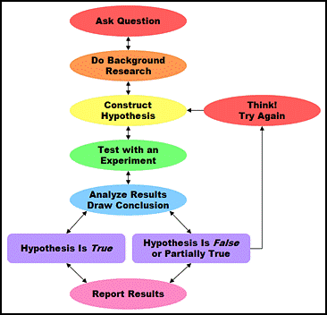
- The scientific method is based on the following steps: _____________________________________________________________ __________________________________________________________________________________________________________________________

- The factors that affect a phenomenon are called _________________
  - _______________________________:________________________________________(ex. Amount of fertilizer used on plants)

  - ___________________________:______________________________ ___________________________________________ (ex. Growth in plants)

  - _____________/Controls:all factors that are _________________ __________________in the experiment so other variables can be studied.

Hypothesis vs Theory vs Law
- A ________________________ is a ______________________________ to a question based on _________________________________
  - It can be _______________________________________ based on ___________ gathered from an experiment.

- A Scientific ___________________ is an _____________for a phenomenon or _________________ that is widely supported by a large body of data
  - Elevated to theory only after many tests and multiple types of experiments
  - The ______________

- A scientific __________ is a summary of many experimental results and observations.
  - Tells ________________________________________________
    - The action-you know an apple will fall if you drop it
  - A law does NOT tell you WHY it happens; that’s the theory

