Unit 2- Basic Chemistry & Minerals
Objectives and Vocabulary

Objectives:

- Explain how elements are related to minerals
- Identify the particles that make up atoms
- Explain what compounds are and why they form
- Compare and Contrast different types of chemical bonds
- Explain a mineral is a naturally-occurring, inorganic, solid substance with a definite chemical composition and structure
- List 5 characteristics of minerals
- Describe the processes resulting in mineral formation
- Explain how minerals can be identified
- Experiment with mineral samples and identify them
- List and describe major groups of minerals
- Explain why color is often not a useful property in identifying minerals
- Define the terms luster, crystal form, streak, and Mohs hardness
- Explain how to test for luster, crystal form, streak, Mohs hardness, and cleavage
- Distinguish between cleavage and fracture
- Explain chemical properties and how they can be used to identify minerals and substances
- Give examples of how minerals are used in the home
- Explain how many minerals are used on average by an American in a lifetime
- Experiment with common household items and compare minerals versus effectiveness of intended use
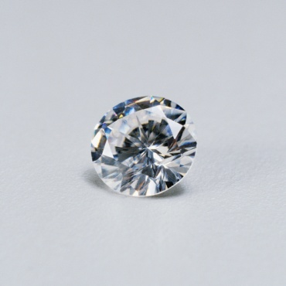

Vocabulary
Element | Atomic number | Energy level | Isotope
Mass number | Compound | Chemical bond | Ionic bond
Covalent bond | Metallic bond | Proton | Neutron
Electron | Mineral | Silicates | Silicon oxygen tetrahedron
Carbonates | Oxides | Sulfides | Sulfates
Halides | Native elements | Color | Streak
Luster | Crystal form | Hardness | Mohs hardness scale
Cleavage | Fracture | Density | Gemstone

