Unit 3-Rock Cycle & Igneous Rocks
Objectives and Vocabulary
Objectives:

- Distinguish between a mineral and a rock
- Identify and differentiate between the three major types of rocks
- Describe the rock cycle
- Provide missing links in a given rock cycle diagram
- List the forces that power the earth’s rock cycle
- Compare and Contrast intrusive and extrusive igneous rocks
- Differentiate the characteristics of mafic and felsic magmas
- Understand the traits of high viscosity magmas and low viscosity magmas
- Describe the basic composition of mafic and felsic magmas
- List the types of magma formed at plate boundaries
- Explain how the rate of cooling affects an igneous rock’s texture
- Describe the features of the main igneous rock textures
- Describe the features of the main igneous rock compositions
- Classify igneous rocks according to texture and composition using an ID guide
- Explain the importance of Bowen’s Series reactions
- Use a Bowen’s Series reactions diagram to predict igneous rock types

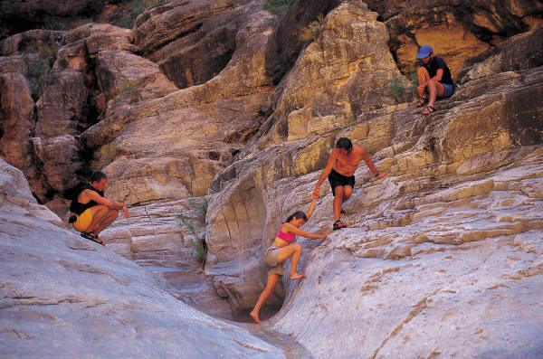
Vocabulary:
Rock | Igneous rock | Sedimentary rock | Metamorphic rock
Rock cycle | Magma | Weathering | Lava
Sediments | Viscosity | Mafic | Felsic
Porphyritic texture | Pyroclastic texture | Phaneritic texture | Aphanitic texture
Glassy Texture

