**Name________________________________________________Period______Date_________**

**Geology Unit 3 Guided Notes**

**Rock Cycle & Igneous Rocks**

Text Reference: Ch 3-66-74

**The rock Cycle**

*Comparing Minerals to Rocks*

|  |  |
| --- | --- |
| **Minerals** | **Rocks** |
|  |  |
|  |  |
|  |  |
|  |  |

*Rocks:*

* Any _______ mass of ______________ or mineral-like matter occurring _______ as part of our planet.

*Types of Rocks*

1. ____________Rocks
   1. Formed by the ____________________ of _________________
2. ____________________Rocks
   1. Formed by the ______________ products of _______________rocks that have been transported, deposited, compacted, and cemented
3. _____________________Rocks
   1. Formed by the _____________of ______________ rock deep within Earth (but still in the ________state) by ________,_____________, and/or chemically active fluids.

*The Rock Cycle*

* Shows the interrelationships among the ______ rock types (_______________,________________________,___________________)
* ___________is the molten material that forms deep beneath the Earth’s ____________
* ___________ is the magma that reaches the ______________
* ___________________ is a process in which rocks are broken down by _________, ________, and ___________________.
* ______________ is weathered pieces of Earth elements.



*Energy that drives the Rock Cycle:*

* Processes driven by the _______from the Earth’s interior are responsible for forming both ______________ and __________________ rocks
* ____________________ and the movement of weathered material are __________ processes powered by energy from the ________
* External processes produce ________________rocks.

**Igneous Rocks & Magma**

* ________ = Latin for fire
* Occurrence
  + Found ____________________
  + Found in discrete geologic locations
    - ______________________plate boundaries
    - ______________________plate boundaries
    - __________________________
* Formed by the ________________ of molten _________.

*The Nature of Igneous Rocks*

* Form from __________________(Greek for paste)
  + Hot, ______________________________ mixture of solid, liquid, and gas
  + Gases: ________________________
  + _________ dense than solid rock
  + ____________________________________________
* Magma vs Lava
  + Magma: molten rock beneath the surface
  + Lava: molten rock that has reached the surface
  + Magma: forms _________________________________________
  + Lava: forms ___________________________________________

*Magma Types and Composition*

* Composition varies widely
  + _____________________ plus major elements
  + Generally a _____________________________ melt
  + __________________________________ control ____________________
  + Silica content used in __________________________
* ___________________ Magmas
  + Silica Content=______________________(LOW)
  + High in ______________________________________________________
  + _________ Temperature molten magma
    - 1000-1200°C (1800-2200°F)
  + Major Minerals:____________________________________________________ ________________________________________
* ___________________ Magma
  + Silica Content: _________________(HIGH)
  + High in __________________________________________________________
  + _____________ temperature magmas
    - ______________________________________
  + Major Minerals: ___________________________________________________

*Magma Viscocity*

* __________________________________________________________________
* High viscosity:______________________________________________________
* Low Viscosity:______________________________________________________
* Controlled by: __________________________________________________________
* As magma cools, _____________________________________________________
* _____________________ controls viscosity

|  |  |
| --- | --- |
| Conditions for High Viscosity (SLOW) | Conditions for Low Viscosity (FAST) |
| * ___________silica * ____________temperatures * _____________Links | * ___________silica * ____________temperatures * _____________Links * Has________________ |

*Plate Tectonic Setting of Igneous Rocks*

* Divergent (plates move apart) Plate Boundaries
  + ____________ melting of magma produces _____________________________
* Congent (plates move together) Plate Boundaries
  + Subduction produces partial metling of _________________________________ ______________________
  + _________________________________________________________________
  + Ascending magma assimilates lower crustal material
* Mantle Plumes
  + Partial melting of plumes of mantle material
  + _________________________________________________________
  + Rising magma produce:
    - ______________________________________________
    - _______________________________________________

*Igneous Rock Classification*

* Igneous rocks are classified by 3 main factors
  + ____________________________________________________________
  + _________________________
  + __________________________________

*Formation of Igneous Rocks*

* **______________** igneous rocks
  + Formed when _____________ hardens beneath earth’s surface
  + See these after __________occurs
  + Example___________________
* ________________ igneous rocks
  + Formed when ____________ hardens
  + Example:_______________

*Texture of Igneous Rocks*

* Texture:
  + The _______________________________________________ of minerals in the rock
  + ________________ history of the magma or lava
  + Crystal size ___________________ as rate of cooling ____________________
  + There are 5 main textures: ___________________________________________ _________________________________________________________________
* Coarse (______________________) Texture
  + _______________ cooling rate
  + _______________ crystals
  + ______________________________________________________
  + Ex: _________________________________________
* Fine (______________________) Texture
  + _______________ cooling rate
  + ________________________________________________ crystals
  + ______________________________________________________
  + Ex: _________________________________________
* Glassy Texture
  + _______________________________ cooling rate
  + ______________________________ crystals
  + ___________________________________
  + Ex: _________________________________________
* PorphyriticTexture
  + _________________cooling history
  + ________________________________________________________
  + ______________________________ crystals
  + Ex: _________________________________________
* Pyroclastic Texture
  + Forms as an explosive ______________________________ mixes fragments of volcano with _____________________ in the atmosphere
  + As this hot combination of tiny ash particles and larger, angular fragments settles to the ground, they blanket the Earth’s surface and weld together
  + Appears ____________________________ with visible crystals
  + A generic term for all these rocks is __________________

*Composition of Igneous Rocks*

* Composition:
  + Which types of minerals make up the rock
  + Compositoin determined by _________________________ reaction series
  + Range from _______________________________________________________ ______________________________________
* Felsic Compositoin
  + Also called ________________________________________ composition
  + ________________ colored rocks
  + ______________________________ in color
  + Mostly composed of ________________________________________________
  + ____________________________________________________
  + ____________________________________________________
  + Examples_____________________________________________
* Intermediate Composition
  + Also called ____________________________________________composition
  + Combination of _________________________________________minerals
  + ____________________________________________________ coloration
  + Mostly composed of: _______________________________________________ _________________________________________________________________
  + __________________________________________________________
  + __________________________________________________________
  + Examples:__________________________________________________
* Mafic Composition
  + Also called ________________________________composition
  + _____________ colored minerals
  + Mostly composed of: _______________________________________________ ____________________________________________
  + ___________________________________________________________
  + ___________________________________________________________
  + Examples:___________________________________________________
* Ultramafic Composition
  + __________________________ colored minerals (usually has ___________________________)
  + Mostly composed of ___________________________________________
  + ____________________________________________________________
  + ____________________________________________________________
  + Examples:____________________________________________________

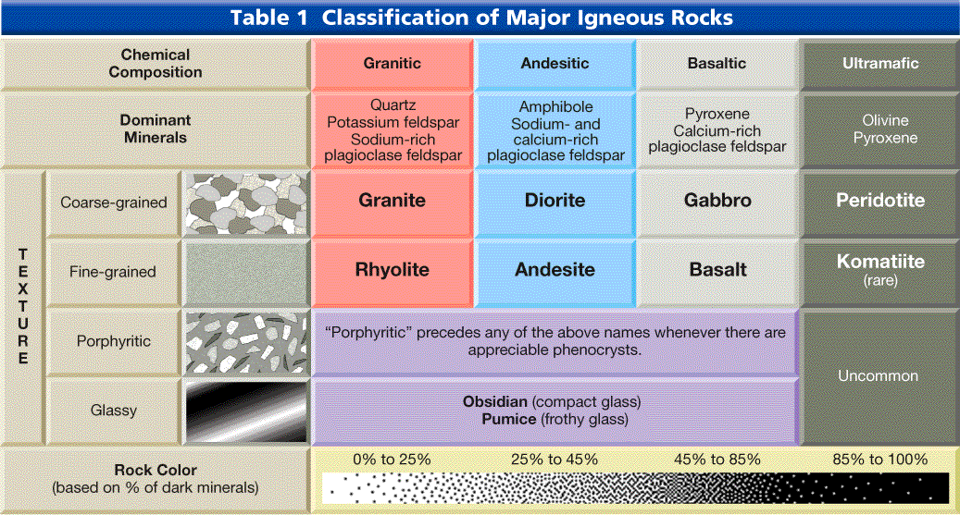

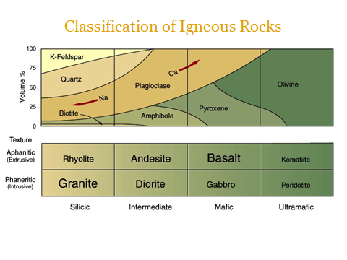



*Bowen’s Reaction Series*

* Chemical evolution of Igneous Rocks proposed by Norma ____________ in the early 1900s
* Proposed _____________________ may evolve by _______________________ _________________________ to produce more ____________________magmas
* Found the following through experiment:
  + There is a regular sequence of silicate material crystallization
    - Minerals common to ______________ rocks crystallize at the ____________ temperatures
    - Minerals common to _____________rocks crystallize at the _________ temperatures
  + Once a mineral forms, it will undergo a __________________________ with the surround melt to produce the ____________________________ _____________________ in the sequence
    - Ex: Olivine undergoes a reaction to form Pyroxene. Then Pyroxene will react to form amphibole, etc.
* Two Important Parts of the reaction series:
  + ______________________ series: includes minerals with differing arrangement of Si-O tetrahedra: (__________________________________ ______________________________)
  + ___________________________series: includes plagioclase feldspar minerals, all of which are framework silicates: (______________________ ____________________________________________________________)

