Name_________________________________________________________ Period_______

Getting to Know Your Chemical Equipment Lab

GOGGLES MUST BE WORN THROUGHOUT THIS LAB!

Introduction
Much of what we know about the physical world has been obtained from measurements in the laboratory. Skill is required to use lab equipment correctly so that errors can be minimized. At the same time, it is important to understand the limitations of scientific measurements.

Materials Needed (listed by station):
- Graduated cylinders of different size (10, 25, 50, 100,1000)
- Beaker, Erlenmeyer flask, clay triangle, crucible, well plate, test tubes, graduated cylinder, glass stir rod, pipette, forceps, funnel, weigh boat, spatula,
- Bunsen Burners, Strikers

STATION 1: Reading Meniscus
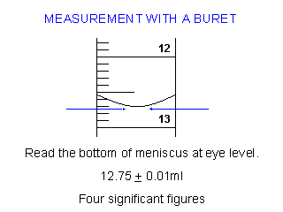
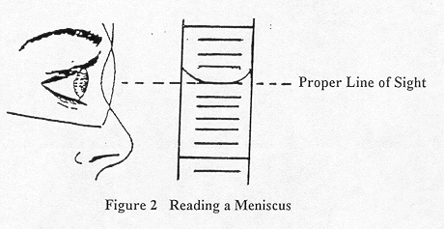
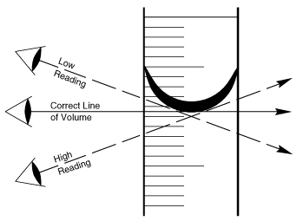

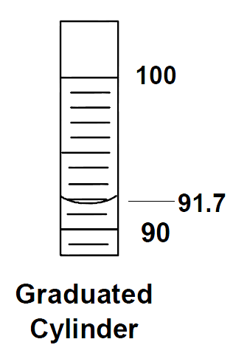
- In all volumetric glassware (graduated cylinder, buret, flasks), it is necessary to read the level of a liquid. To read the level of a liquid, look at the bottom of the meniscus (see above figures).

- Always estimate the last digit. For example, the 100 mL graduated cylinder has one mL graduations. I would estimate the volume to the 91.7(see to the right)

PROCEDURE:
- At your lab station, read the amount of liquid in the graduated cylinders at letters A, B, C, D, & E. Record your observations below.

 | A | B | C | D | E
Graduated Cylinder Size | 1000 mL | 100 mL | 50 mL | 25 mL | 10 mL
Amount of Liquid
STATION 2: ID of Lab Equipment & Using Balances

PROCEDURE PART I- ID of Lab Equipment
  - Look at the equipment on the table, record the name, a sketch of the equipment, and write the use of the equipment.

 | Equipment  Name | Equipment  Sketch | Equipment  Use
A
B
C
D
E
F
G
H
I
J
K
L
M

Part II: Using Balances
- These balances are expensive, and great care must be taken when using them.
- General Rules: Use a weigh boat or small glass beaker to measure out chemicals with clean and dry spatulas! If you spill chemicals on the balance or around the balance on the lab table, CLEAN IT UP.

PROCEDURE PART II
- Obtain a weigh boat, and place it on the balance.
- To remove the mass of the weigh boat, hit the ZERO or TARE button.
- Obtain approximately 1.5 grams of NaCl using a spatula. Record actual amount used (BE SURE TO INCLUDE UNITS).
- Throw away weigh boat and NaCl, and clean up any many made around the balance.

Mass of NaCl Obtained | ______________
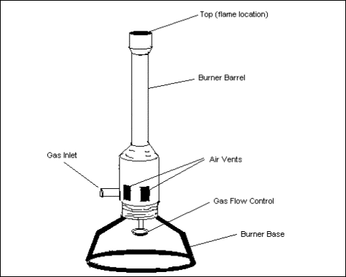
STATION 3: Using Bunsen Burners

NEVER use a Bunsen burner near flammable materials; heat a test tube or container that has a lid, stopper, or cap; never have loose clothing or long hair near the flame
IN CASE OF AN EMERGENCY…TURN OFF THE GAS!
Figure 1: Anatomy of a Bunsen Burner

PROCEDURE:

1. At your desk there is a sliver-colored gas outlet. The outlet is ON when the handle points toward the nozzle and it is OFF when the handle is perpendicular to the nozzle. This outlet should be OFF before and after you use the Bunsen burner.

2. Check to see if the rubber hose is attached tightly to the Bunsen burner. Then attach the rubber hose to the nozzle of the gas outlet.

3. The gas flow control on the burner is a knob underneath the burner. This knob is OFF when it is screwed into the base of the burner. Unscrewing the knob will let gas flow. Make sure this knob is in the OFF position at this point.

4. The flow of air to the burner is controlled by the position of the burner barrel. Adding air makes the flame hotter. Turning the tube or barrel counterclockwise allows more air to be mixed with the gas making a hot BLUE flame. For now, turn the tube clockwise and close it, then turn counterclockwise ½ a turn

Gas = ORANGE/YELLOW Warm Flame
Gas + Air = BLUE Hot Flame

5. Turn ON the Gas outlet by pointing the handle toward the end of the nozzle. DO NOT use the outlet to change the amount of gas going to the Bunsen burner.

6. Use the strike to produce a spark. Hold it next to the top edge of the burner. Turn the gas knob clockwise on the bottom of the Bunsen burner until the burner lights (about ½ turn). Light the Bunsen burner. The flame should be ORANGE/YELLOW at this point.

7. Change the height of the flame by turning the gas flow control at the bottom of the burner. Turning this knob clockwise will make the flame larger. Turning the gas knob counterclockwise will make the flame smaller. Adjust this knob to give a flame about 3 inches high.

8. Now add air by turning the tube/barrel of the burner. If you add too much air, the flame will make a hissing noise and may even go out. If you don’t add enough air, then your flame will not be hot enough for most of the labs in this class. Add just enough air to give a DARK BLUE flame that burns quietly with an inner LIGHT BLUE cone.

9. Obtain teacher signature to verify correct usage of Bunsen burner. Both Partners will have to use Bunsen burner separately.

