Molecular Shapes Lab Name:

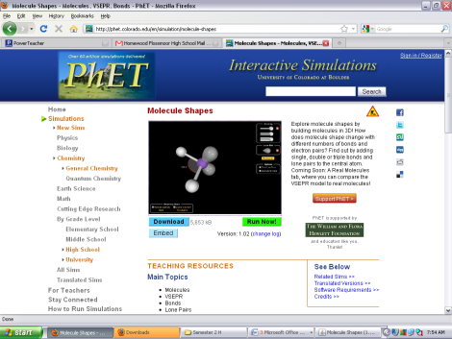
Purpose: You will use a 3D computer simulator to determine patterns in molecular geometry and electron geometry. By the end of this lab, you should be able to determine the shape of a basic molecule based on the bonds and electron pairs surrounding the central atom.

Step 1: Go to http://phet.colorado.edu/en/simulation/molecule-shapes
(or Google “phet molecular shapes”)
Step 2: Run the simulator
Step 3: Check “Molecule Geometry”
Step 4: Check Show Lone Pairs & Show Bond Angles
Step 4: Create the molecules listed below by adding and removing
single-bonded atoms and electron clouds.

Under the Model Tab…
Single Bond | Lone Pairs | Molecule Geometry | Bond Angle | Sketch
1 | 0
2 | 0
2 | 2
3 | 0
3 | 1
4 | 0
5 | 0
6 | 0

Under the Real Molecules Tab
- Check to make sure ONLY molecular geometry tab is checked
- Check to make sure Show Lone Pairs & Show Bond Angles is Checked
- Check to make sure Model is checked, not real
- Fill in the chart below by selecting different molecules (except don’t fill in last column yet)
- Go back and select real button. Go back through and recheck your bond angles and fill out last column

Molecule | Total Bonds | Lone Pairs | Molecule Geometry | Bond Angle | Sketch
H₂O
CO₂
SO₂
BF₃
NH₃
CH₄
PCl₅
SF₆

Questions:
What general patterns exist for identifying the Molecule Geometry of a molecule?

How did the bond angles differ from the model to real atoms? Give an explanation for why you think this occurs?

