Name_______________________________________________Period______Date______________

Wave Interaction Practice

- What is meant by the term reflection?

- Draw a picture showing FREE reflection.

- Draw a picture showing ATTACHED reflection.

- Draw a picture of what happens to light as it passes through a window based on diffraction.

- What is refraction?

- Where can you see refraction?

- Where does light travel faster: through a liquid or gas? EXPLAIN!

- What is the difference between a constructive and destructive interference?

- What variable has to be the same for waves to interfere?

- Draw a picture of a standing wave and label the nodes and antinodes.

- Where on a standing wave is there complete constructive interference or the maximum point of vibration?

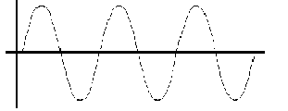
For the following questions draw the resulting interference and identify what type of interference is shown. (REMEMBER constructive is like adding, destructive is like subtracting)

- Type of interference______________________ Resulting Amplitude______ Draw Picture Below

- Type of interference______________________ Resulting Amplitude______ Draw Picture Below

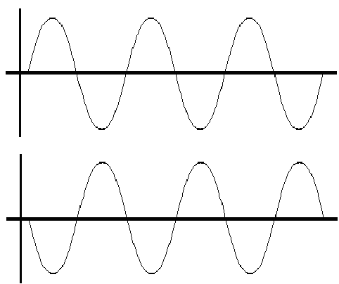

- Type of interference______________________ Resulting Amplitude______ Draw Picture Below
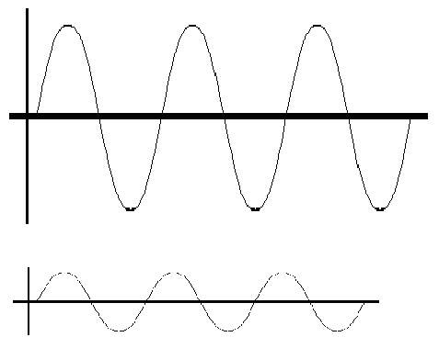

- Type of interference______________________ Resulting Amplitude______ Draw Picture Below
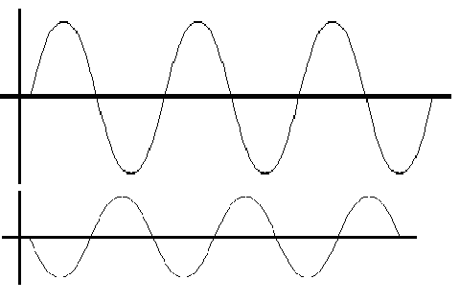

- Type of interference______________________ Resulting Amplitude______ Draw Picture Below

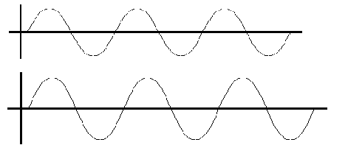

- Type of interference______________________ Resulting Amplitude______ Draw Picture Below

