Name_____________________________________________Period_____Date__________________

Weather Symbols Homework

Directions: Use the map below to answer the questions
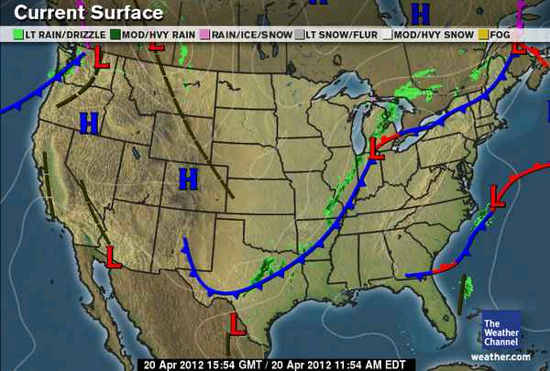

- Draw the symbol for low pressure

- Draw the symbol for high pressure

- Draw the symbol for a cold front

- Draw the symbol for a warm front

- Draw the symbol for a stationary front

- Look at the map point labeled A. What type of weather is likely occurring here?

- Look at the map point labeled B. What type of weather is likely occurring here?

- Is the air getting drier, more humid, or neither in a cold front?

- Is the air getting drier, more humid, or neither in a warm front?

- Is the air getting drier, more humid, or neither in a stationary front?

- On your map put a circle in an area you think will likely see rain tomorrow.

- On your map put a square in an area you think will be sunny tomorrow.

- In which direction do cold fronts usually move?

- In which directions do warm fronts usually move?

- Does cold front always mean cold temperatures?

- Does a warm front always mean warm temperatures?

- Does low pressure always mean rain? What else could occur with low pressure systems?

- Do you think you can understand the weatherman better after today?

