Name__________________________________________________Period_____Date______________

Wedges Practice

Answer the questions below:

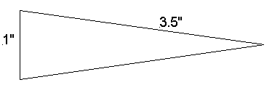 | 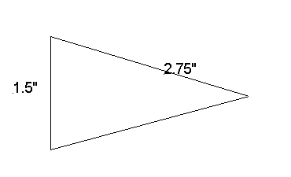
MA= | MA=
If you wanted a wedge with an MA of 5, how much wider would the wedge need to be? (HINT: the flat side) | If you wanted a wedge with an MA of 3.25, how much longer would the wedge need to be? (HINT: the sloped side?
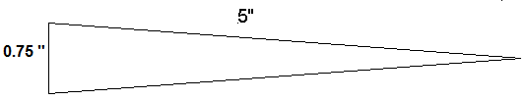 | 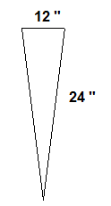
MA= | MA=
If you wanted a wedge with an MA of 9, how much longer would the wedge need to be? (HINT: the sloped side? | If you wanted a wedge with an MA of 2.5, how much wider would the wedge need to be? (HINT: the flat side)
Answer the following questions: (BE CAREFUL WHICH TRIANGE YOU USE!)

- While chopping wood with an axe, you use a force 60 N to split a log. If the axe has a mechanical advantage of 3.5, what is the maximum force of the wood you can split?

- A wedge with a mechanical advantage of 0.78 is used to raise a house corner from its foundation. If the output force is 7500 N, what is the input force?

- You are out to eat with your family, and you use a knife to cut your food. If the knife is 1 inch wide and the sloped- side is 6.5 inches long, what is the mechanical advantage of the knife?

- The doorstop holding open the classroom door is 2 inches wide and has a slope length of 5.5 inches. What is the mechanical advantage of this machine?

- An axe is used to split wood is driven into a piece of wood a distance of 3 cm. If the mechanical advantage of the axe is 0.85, how far apart is the wood split?

