Name__________________________________Period_____Date_____________

Wheel and Axle Practice

Answer the following questions:

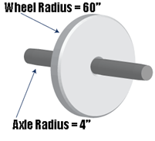 | 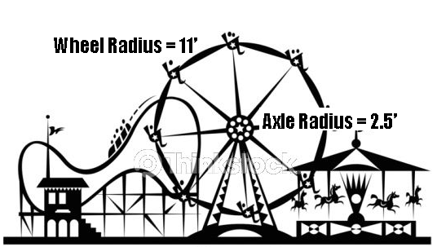
r_{e}= | r_{e}=
r_{r}= | r_{r}=
IMA= | IMA=
If the Actual MA is 10, how wide does the wheel need to be? (Remember, the width will be equal to r_{e} + r_{e}) | If the Actual MA is 3, how wide does the axle need to be? (Remember, the width will be equal to r_{r} + r_{r})
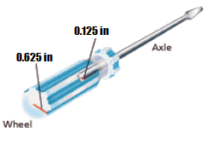 | 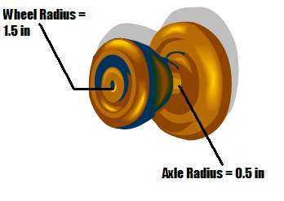
r_{e}= | r_{e}=
r_{r}= | r_{r}=
IMA= | IMA=
If the Actual MA is 2.5, how wide does the wheel need to be? (Remember, the width will be equal to r_{e} + r_{e}) | If the Actual MA is 2, how much wider does the axle need to be (HINT: you will need to subtract at the end)
Answer the following questions below:

- Draw a wheel and axle with a mechanical advantage of 5.

- What is the mechanical advantage of a wheel and axle that uses 50 N of force to move a resistance of 2550 N? (HINT: Pick your triangle carefully, you have forces not lengths!)

- The mechanical advantage of an automobile’s wheel and axle is 8.93 x 10⁻². If the wheel’s output force is 2.22 x 10³ N. What is the input force that turns the axle?

- What does the radius of the axle of a wheel need to be if it has a mechanical advantage of 3.9 and the wheel has a radius of 18 inches?

- The diameter of a steering wheel in Allyson’s car is 15 inches. The steering column (or the axle of the steering wheel) has a radius of 1.75 inches. What is the mechanical advantage provided by this simple machine? (BE SURE TO CONVERT DIAMETER TO RADIUS by dividing the diameter by 2)

- An industrial water shutoff valve is designed to operate with 40 lb of effort force. The valve with encounter 250 lb of resistance force when applied to a 1.25 in axle radius.
  - What is the mechanical advantage of the system (HINT: use forces)

  - What is the required wheel radius to overcome the resistance force? (HINT: use answer from part A)

